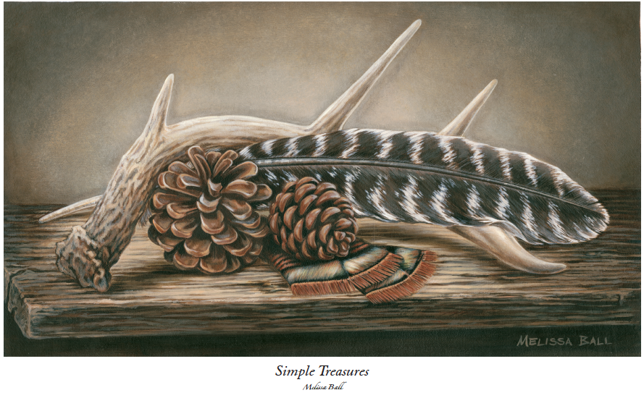
TWEP Building Campaign 2014
Order form for “Simple Treasures” by Melissa Ball

Purchaser information:
Name_______________________________
Home Phone _________________________ Cell Phone__________________________
Address ____________________________ City/State/Zip_________________________
Email________________________________

Payment Information
I would like to purchase the following: __________ unframed print @$30/each
__________ framed print @$125/each
_______ check enclosed for $_____________ (check payable to TWEP)
_______ Please charge my ______ Visa ______ Mastercard _______ Discover Card
Amount to charge: $________________ Card #:________________________ Zip Code:______
Name on Card: ____________________________ Expiration Date: ________ Auth. Code: ____
I authorize TWEP to charge my credit card to the amount shown above.
Card Holder Signature: ________________________________________
Email to which you would like receipt sent: ________________________

