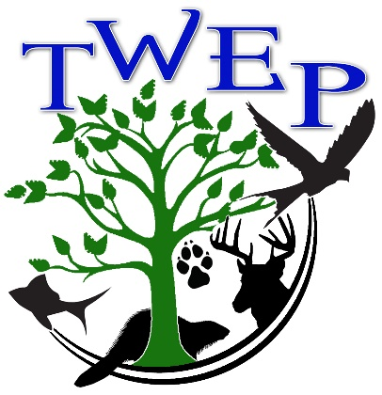
ENTRY FORM
TWEP NATURE Art Contest 2024

Display and Winners Announced: Sunday, April 7- 2:00-4:00

Entry forms, together with the art may be dropped off at the Charles Brightbill Environmental Center on Tuesday, 9 - 12 or Thursday, 1-3 throughout March. Call the Center to make alternative arrangements for drop off. (717 328-2126)
Deadline is April 3 , 2024.

Name: ________________________________________________________________

Address: _______________________________________________________________

Phone (area code first) _______________________________________________________

E-mail address: ______________________________________

School (if student):______________________________________________

Teacher (if applicable):___________________________________________

ENTRY Medium: _______________________________________

TITLE: _____________________________________________________________

Any special comments:

Tuscarora Wildlife Education Project is located in The Charles Brightbill Environmental Center, located behind James Buchanan High School, 4881 Fort Loudon Road, P.O. Box 97, Mercersburg, PA 17236

For further information, please call the Center at 328-2126 or e-mail twepmail@gmail.com

